BANK LOAN – FULL REPORT

Key Performances indicators (KPIs) Requirements

- Total Loan Applications:
We need to calculate the total number of loan applications received during a specified period. Additionally, it is essential to monitor the Month-to-Date Loan Applications and track changes Month-over-Month

- Total Funded Amount:
Understanding the total amount of funds disbursed as loans is crucial. We also want to keep an eye on the MTD Total Funded Amount and analyze the Month-over-Month changes in this metric.

- Total Amount Received:
Tracking the total amount received from borrowers is essential for accessing the bank’s cash flow and loan repayment. We should analyze the Month-to-Date Total Amount Received and observe the Month-over-Month changes.

- Average Interest Rate:
Calculating the average interest rate across all loans, MTD, and monitoring the Month-over-Month variances in interest rates will provide insights into our lending portfolio’s overall cost.

- Average Debt-to-Income Ratio (DTI):
Evaluating the average DTI for our borrowers helps us gauge their financial health. We need to compute the average DTI for all loans, MTD, and track MONTH-over-Month fluctuations.

Functionalities Will Be Using

SQL – MS SQL Server

- Creating database
- Creating table
- Select
- Datename
- Datepart
- Cast
- Decimal
- Month
- Hour
- Quarter
- Day
- Group By
- Order By
- Decimal
- Limit
- Count
- Distinct
- CTE
- Partition

POWER BI

- Connecting to SQL Server
- Data Cleaning
- Data Modelling
- Data Processing
- Power Query
- Date Tables
- Time Intelligence Func
- DAX
- Date Function
- Text Function
- Filter Function
- Calculate
- SUM/SUMX
- Creating KPI’s
- New Card Visual
- Creating charts
- Formatting visuals
- Creating Functions
- Navigations

Domain Knowledge
Bank loans are a crucial financial tool that enables individuals and businesses to achieve their goals and manage financial needs. However, it's essential for borrowers to understand the terms, costs, and responsibilities associated with loans to make informed financial decisions.
Banks collect loan data through various channels and processes, including:
Loan Applications:
When individuals or businesses apply for loans, they submit detailed applications that include personal and financial information. This data is collected electronically or in paper form.
Credit Reports:
Banks often access credit reports from credit bureaus when assessing a borrower's creditworthiness. These reports contain information about a person's credit history, existing loans, and payment behaviour.
Internal Records:
Banks maintain internal records of loan transactions, including disbursements, repayments, and loan status changes. These records are generated and stored in the bank's database.
Online Portals:
Many banks offer online platforms where borrowers can apply for loans, make payments, and access account information. Data from these portals is collected and stored for analysis.
Third-party Data Sources:
Some banks may use external data sources, such as income verification services, to gather additional information about borrowers.

Process of Granting a Loan

Loan Application:
The process begins when a customer submits a loan application to a bank or lending institution. This application can be submitted in person, online, or through other channels.

Application Review:
The lending institution reviews the loan application and collects necessary documentation, such as income statements, credit reports, and identification documents.

Identity Verification:
One of the initial checks is to verify the applicant's identity. This helps ensure that the applicant is who they claim to be and prevents identity theft.

Credit Check:
A crucial step is to perform a credit check on the applicant. This involves accessing their credit report from credit bureaus. Lenders evaluate the applicant's credit history, credit score, and any past delinquencies or defaults.
Income Verification:
Lenders assess the applicant's ability to repay the loan by verifying their income. This may involve reviewing pay stubs, tax returns, or other income documentation.

Debt-to-Income Ratio (DTI) Check:
Lenders calculate the applicant's DTI, which is the ratio of their monthly debt payments to their monthly income. A lower DTI indicates better repayment capacity.

Employment Verification:
Lenders may contact the applicant's employer to verify their employment status and length of employment. Stable employment history is often seen as a positive factor.

Collateral Assessment (if applicable):
If the loan is secured by collateral, such as a home or a car, the lender evaluates the value and condition of the collateral.

Risk Assessment:
Lenders assess the overall risk associated with the loan. This includes considering the applicant's credit risk, income stability, and the purpose of the loan.

Loan Approval or Denial:
Based on the information gathered and the risk assessment, the lender makes a decision to approve or deny the loan application. If approved, the lender determines the loan amount, interest rate, and terms.

Loan Agreement:
If the loan is approved, the lender provides the applicant with a loan agreement that outlines the terms and conditions, including the interest rate, repayment schedule, and any fees.

Disbursement of Funds:
Once the loan agreement is signed by both parties, the lender disburses the funds to the borrower. The borrower can use the funds for the specified purpose.

Repayment:
The borrower is responsible for making regular loan payments as specified in the loan agreement. This includes repaying the principal amount along with interest.

Ongoing Monitoring:
Lenders continue to monitor the loan throughout its term, including tracking payments, assessing the borrower's financial health, and managing any delinquencies or defaults.

Reasons for Analysing Bank Loan Data:
Banks analyse loan data for several critical reasons:
Risk Assessment:
One of the primary purposes of analysing loan data is to assess the risk associated with lending to a particular individual or business. Banks use data to evaluate the creditworthiness of borrowers, predict default probabilities, and determine interest rates and lending terms.
Decision-making:
Loan data analysis supports the decision-making process when evaluating loan applications. Banks use data-driven models and algorithms to make informed lending decisions, such as approving or denying loan requests.
Portfolio Management:
Banks manage portfolios of loans, including mortgages, personal loans, and business loans. Data analysis helps banks monitor the health of these portfolios, identify underperforming loans, and optimize loan terms and pricing.

Fraud Detection:
Banks use data analysis to detect fraudulent loan applications and activities. Unusual patterns, inconsistencies, or discrepancies in loan data can trigger fraud alerts.
Regulatory Compliance:
Banks are subject to regulatory requirements that mandate the collection and reporting of loan data. Compliance with regulations such as the Home Mortgage Disclosure Act (HMDA) and the Know Your Customer (KYC) regulations requires data analysis and reporting.
Customer Insights:
Analysing loan data provides insights into customer behaviour, preferences, and needs. Banks can use these insights to tailor loan products and marketing strategies to specific customer segments.
Profitability Analysis:
Banks assess the profitability of their loan portfolios by analysing data related to interest income, loan origination costs, default rates, and collection efforts.
Market Research:
Data analysis helps banks understand market trends, competitive landscape, and customer demand. This information guides product development and market expansion strategies.
Credit Risk Management:
Banks continuously monitor and manage credit risk associated with their loans. Data analysis helps in setting risk management strategies, provisioning for potential losses, and stress testing loan portfolios.
Customer Retention:
Banks use data analysis to identify opportunities for retaining existing customers, such as offering loan refinancing options or additional financial products.

Bank Loan Report Query Document

KPI’s

Total Loan Application
SELECT COUNT(id) AS MTD_Total_Loan_Applications
FROM bank_loan_data

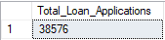

Mont-to-Date Loan Application
SELECT COUNT(id) AS MTD_Total_Loan_Applications
FROM bank_loan_data
WHERE MONTH(issue_date) = 12 AND YEAR(issue_date) = 2021
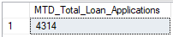

PMont-to-Date Loan Application
SELECT COUNT(id) AS MTD_Total_Loan_Applications
FROM bank_loan_data
WHERE MONTH(issue_date) = 11 AND YEAR(issue_date) = 2021
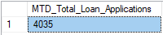
______________________________________________________________________________________________________

Total Funded Amount
SELECT SUM(loan_amount) AS Total_Funded_Amount
FROM bank_loan_data
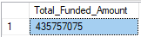

MTD Total Funded Amount
SELECT SUM(loan_amount) AS MTD_Total_Funded_Amount
FROM bank_loan_data
WHERE MONTH(issue_date) = 12 AND YEAR(issue_date) = 2021

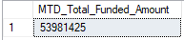

PMTD Total Funded Amount
SELECT SUM(loan_amount) AS MTD_Total_Funded_Amount
FROM bank_loan_data
WHERE MONTH(issue_date) = 11 AND YEAR(issue_date) = 2021

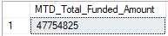

Total Amount Received
SELECT SUM(total_payment) AS Total_Amount_Received
FROM bank_loan_data

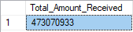

MTD Total Amount Received
SELECT SUM(total_payment) AS Total_Amount_Received
FROM bank_loan_data
WHERE MONTH(issue_date) = 12 AND YEAR(issue_date) = 2021

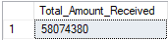

PMTD Total Amount Received
SELECT SUM(total_payment) AS Total_Amount_Received
FROM bank_loan_data
WHERE MONTH(issue_date) = 11 AND YEAR(issue_date) = 2021

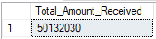

____________________________________________________________________________________________________

Average Interest Rate (%)
SELECT ROUND(AVG(int_rate) * 100,2) AS Avg_Int_Rate
FROM bank_loan_data

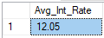

MTD Average Interest (%)
SELECT ROUND(AVG(int_rate) * 100,2) AS Avg_Int_Rate
FROM bank_loan_data
WHERE MONTH(issue_date) = 12

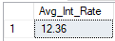

PMTD Average Interest
SELECT ROUND(AVG(int_rate) * 100,2) AS Avg_Int_Rate
FROM bank_loan_data
WHERE MONTH(issue_date) = 11

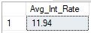
____________________________________________________________________________________________________

Average Debt-to-Income Ratio (%)
SELECT AVG(dti) * 100 AS Avg_DTI
FROM bank_loan_data

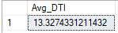

MTD Average Debt-to-Income Ratio (%)
SELECT AVG(dti) * 100 AS Avg_DTI
FROM bank_loan_data
WHERE MONTH(issue_date) = 12

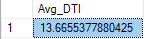

PMTD Average Debt_to_Income Ratio(%)
SELECT AVG(dti) * 100 AS Avg_DTI
FROM bank_loan_data
WHERE MONTH(issue_date) = 11

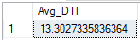

____________________________________________________________________________________________________

GOOD LOAN ISSUED

Good Loan Percentage (%)
*note: considering ‘Fully Paid’ and ‘Current’ loan status as included in as a good loan
-- to check the unique values inside the loan_status column
SELECT DISTINCT(loan_status)
FROM bank_loan_data

-- find the good loan considering the status assigned
SELECT CAST(ROUND((COUNT(CASE WHEN loan_status = 'Fully_Paid' OR loan_status = 'Current' THEN id END) * 100.0) /COUNT(id),2) AS DECIMAL(10,2)) AS Good_Loan_Percentage
FROM bank_loan_data

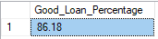

Good Loan Applications
SELECT COUNT(id) AS Good_Loan_Application
FROM bank_loan_data
WHERE loan_status = 'Fully_Paid' OR loan_status = 'Current'

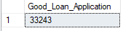

Good Loan Funded Amount
SELECT SUM(loan_amount) AS Good_Loan_Funded_Amount
FROM bank_loan_data
WHERE loan_status = 'Fully Paid' OR loan_status = 'Current'

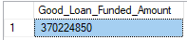

Good Loan Amount Received
SELECT SUM(total_payment) AS Good_Loan_Amount_Received
FROM bank_loan_data
WHERE loan_status = 'Fully Paid' OR loan_status = 'Current'

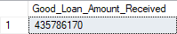

BAD LOAN ISSUED

Bad Loan Percentage (%)
-- checking unqiue values in loan_status column
SELECT DISTINCT(loan_status) AS type_of_status
FROM bank_loan_data

SELECT
CAST(ROUND((COUNT(CASE WHEN loan_status = 'Charged Off' THEN id END) * 100.0) /
COUNT(id), 2) AS DECIMAL (10,2)) AS Bad_Loan_Percentage
FROM bank_loan_data

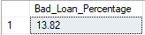

Bad Loan Application
SELECT COUNT(loan_status) AS Bad_Loan_Application
FROM bank_loan_data
WHERE loan_status = 'Charged Off'

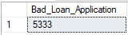

Bad Loan Funded Amount
SELECT SUM(loan_amount) AS Bad_Loan_Funded_Amount
FROM bank_loan_data
WHERE loan_status = 'Charged Off'

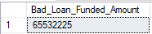

Bad Loan Amount Received
SELECT SUM(total_payment) AS Bad_Loan_Amount_Received
FROM bank_loan_data
WHERE loan_status = 'Charged Off'

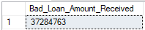

____________________________________________________________________________________________________

LOAN STATUS
SELECT
loan_status,
COUNT(id) AS Loan_Count,
SUM(total_payment) AS Total_Payment_Received,
SUM(loan_amount) AS Total_Funded_Amount,
AVG(int_rate * 100) AS Interest_Rate,
AVG(dti * 100) AS DTI
FROM bank_loan_data
GROUP BY loan_status

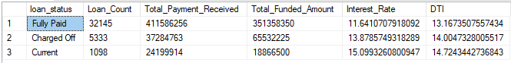

SELECT
loan_status,
SUM(total_payment) AS MTD_Total_Amount_Received,
SUM(loan_amount) AS MTD_Total_Funded_Amount

FROM bank_loan_data
GROUP BY loan_status

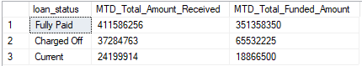

____________________________________________________________________________________________________

BANK LOAN REPORT | OVERVIEW

MONTH
SELECT
MONTH(issue_date) AS Month_Number,
DATENAME(MONTH, issue_date) AS Month_Name,
COUNT(id) AS Total_Loan_Applications,
SUM(loan_amount) AS Total_Funded_Amount,
SUM(total_payment) AS Total_Amount_Received
FROM bank_loan_data
GROUP BY MONTH(issue_date), DATENAME(MONTH, issue_date)
ORDER BY MONTH(issue_date)

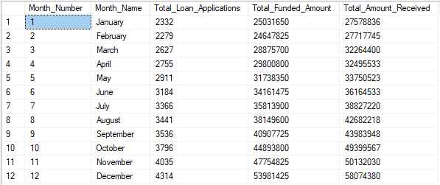

STATE
SELECT
address_state AS State,
COUNT(id) AS Total_Loan_Applications,
SUM(loan_amount) AS Total_Funded_Amount,
SUM(total_payment) AS Total_Amount_Received
FROM bank_loan_data
GROUP BY address_state
ORDER BY address_state

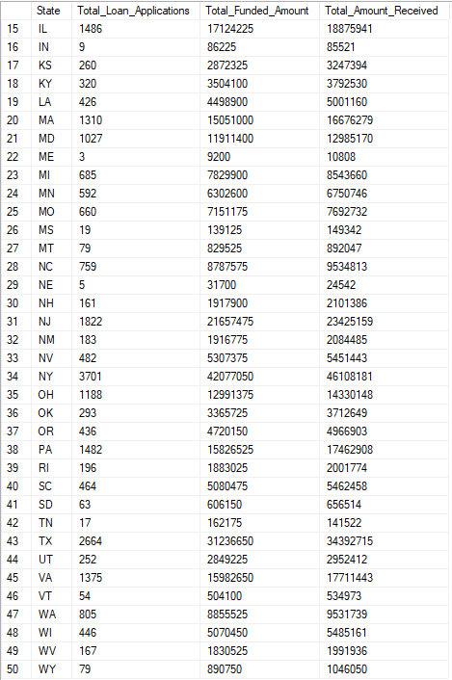

TERM
SELECT
term AS Term,
COUNT(id) AS Total_Loan_Applications,
SUM(loan_amount) AS Total_Funded_Amount,
SUM(total_payment) AS Total_Amount_Received
FROM bank_loan_data
GROUP BY term
ORDER BY term
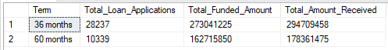

EMPLOYEE LENGTH
SELECT
emp_length AS Employee_Length,
COUNT(id) AS Total_Loan_Applications,
SUM(loan_amount) AS Total_Funded_Amount,
SUM(total_payment) AS Total_Amount_Received
FROM bank_loan_data
GROUP BY emp_length
ORDER BY emp_length
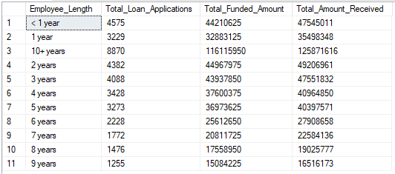

PURPOSE
SELECT
purpose AS PURPOSE,
COUNT(id) AS Total_Loan_Applications,
SUM(loan_amount) AS Total_Funded_Amount,
SUM(total_payment) AS Total_Amount_Received
FROM bank_loan_data
GROUP BY purpose
ORDER BY purpose
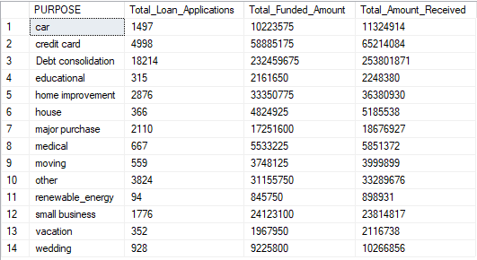

HOME OWNERSHIP
SELECT
home_ownership AS Home_Ownership,
COUNT(id) AS Total_Loan_Applications,
SUM(loan_amount) AS Total_Funded_Amount,
SUM(total_payment) AS Total_Amount_Received
FROM bank_loan_data
GROUP BY home_ownership
ORDER BY home_ownership
